

VISVESVARAYA TECHNOLOGICAL UNIVERSITY BELAGAVI - 590018.
Second Year

A Mini-Project For MongoDB Lab On
“MongoDB Queries on Inventory Management System”

Course Code: BDSL456B — MongoDB

Submitted in partial fulfilment of the requirement for the award of the Degree of

Bachelor of Engineering In
Artificial Intelligence and Data Science Engineering
Submitted by

Srivathsa .S (1HC24AD042)



Under the guidance of Dr NanditaYambem Associate Professor

Department of Artificial Intelligence and Data Science
Dr H N National College of Engineering
(Approved by AICTE, Affiliated to VTU, Belagavi) 36B Cross, Jayanagar 7th block, Bengaluru – 560070


DR. H N NATIONAL COLLEGE OF ENGINEERING
(Affiliated to VTU, Belagavi, Approved by AICTE, New Delhi and Government of Karnataka)

DEPARTMENT OF AI&DS


2025-2026

Certificate

This is to certify that the Mini Project Work entitled “MongoDB Queries on Inventory Management System” is a bonafide work carried out by Srivathsa . S (1HC24AD042), in partial fulfilment for the IV semester of Bachelor of Engineering in AI&DS of the Visvesvaraya Technological University, Belgaum during the year 2025- 2026. The Project report has been approved as it satisfies the academics prescribed for the Bachelor of Engineering degree.

Signature of Guide: Signature of HOD:


CONTENTS

Chapter 1 Introduction Pg No.1-3

  - CAP Theroem
  - MongoDB
  - NoSQL and RDBMS similarities and differences

Chapter 2 CRUD Operations in MongoDB Pg No.4

Chapter 3 Flow Diagram and Project Description. Pg No.5-8

  - Flow Diagram
  - Source Data
  - Tech Stack Used
  - Explanation of the data

Chapter 4 Analytical Questions and MongoDB Solutions Pg No.9-16

Chapter 5 Additional Technologies Used. Pg No.17

Chapter 6 Conclusion Pg No. 18


Chapter 1 Introduction
  - CAP Theorem
The CAP theorem, also known as Brewer's theorem, is a principle in distributed systems theory that describes the trade-offs between three key properties of a distributed database system:
Consistency: Every read receives the most recent write (or an error). This means that all nodes in the system have the same data at any given time. If a write operation is completed, all subsequent read operations should return the updated value.
Availability: Every request (read or write) receives a response, whether it is the requested data or an error. This ensures that the system is operational and responsive at all times. Partition Tolerance: The system continues to operate despite arbitrary partitioning due to network failures or other issues. This means that the system can handle situations
where some nodes or communication paths become unavailable.
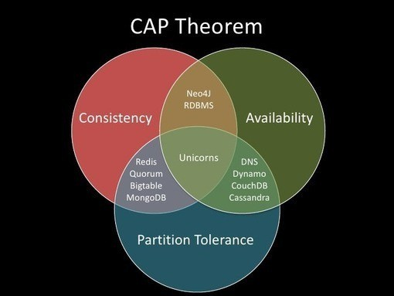

Key Points
Consistency and Availability (CA): In a system that prioritizes consistency and availability, the system must respond with the latest data, and it must do so for every request. However, if there is a network partition, the system might not be able to guarantee consistency or availability.
Consistency and Partition Tolerance (CP): In a system that prioritizes consistency and partition tolerance, the system ensures that all nodes have the same data, even during network partitions. However, this may come at the cost of availability.
Availability and Partition Tolerance (AP): In a system that prioritizes availability and partition tolerance, the system remains operational and responsive, even during network partitions. However, it may sacrifice consistency
Department of AI&DS, DrHNNCE 1


Practical Implications Distributed systems can only provide two of the three properties simultaneously:
    - CA Systems: Systems like traditional relational databases may provide strong consistency
and high availability but cannot tolerate network partitions. They are often designed for environments with reliable network connectivity.
    - CP Systems: Systems like some distributed databases (e.g., HBase) may focus on consistency and partition tolerance, which can lead to temporary unavailability during network partitions
    - AP Systems: Systems like many NoSQL databases (e.g., Cassandra, Couchbase) prioritize availability and partition tolerance, which can result in temporary inconsistencies in the data.

MongoDB
MongoDB is a leading NoSQL database management system designed for handling large volumes of unstructured data with flexibility and scalability. Unlike traditional relational databases, MongoDB uses a document-oriented model where data is stored in JSON-like BSON documents, allowing for a dynamic schema and rich, nested data structures. Key features include horizontal and vertical scaling, high availability through replication, and a robust aggregation framework. It is ideal for content management, real-time analytics, IoT, e- commerce, and social networks.

NoSQL and RDBMS Similarities and Differences

Similarities:
Data Storage: Both NoSQL and Relational Database Management Systems (RDBMS) are used to store data. They ensure data is saved in a structured manner, although the structure varies.
Querying Capabilities: Both types of databases offer querying mechanisms to retrieve and manipulate data. RDBMS uses SQL (Structured Query Language), while NoSQL databases have their own query languages or APIs.
Data Management: Both systems provide functionalities to manage data effectively, including insertion, updates, and deletions.
Indexes: Both types of databases use indexing to improve query performance. Indexes speed up data retrieval by creating pointers to the data.

Differences:

Data Model:
RDBMS: Uses a structured schema where data is organized into tables with rows and columns. Each table represents an entity, and relationships between tables are defined using foreign keys.
Department of AI&DS, DrHNNCE 2


NoSQL: Employs various data models, including document-oriented, key-value pairs, column-family, and graph databases. This flexibility allows for unstructured, semi- structured, or hierarchical data.

Schema Flexibility:
RDBMS: Requires a predefined schema. Any changes to the schema, such as adding a new column, necessitate altering the database structure, which can be complex and time-consuming.
NoSQL: Offers schema flexibility, allowing for dynamic and evolving data models. This is particularly advantageous for applications with rapidly changing requirements or diverse data types.

Scalability:
RDBMS: Typically scales vertically by increasing the power of a single server (CPU, RAM, etc.). Horizontal scaling (scaling out across multiple servers) is more challenging and less common.
NoSQL: Designed for horizontal scalability, allowing for easy distribution of data across multiple servers. This makes it more suitable for handling large-scale, high-traffic applications.

Consistency and Transactions:
RDBMS: Emphasizes ACID (Atomicity, Consistency, Isolation, Durability) properties, ensuring reliable transactions and data consistency.
NoSQL: Often follows the BASE (Basically Available, Soft state, Eventually consistent) model, which provides high availability and performance but with eventual consistency rather than strict ACID guarantees.

Use Cases:
RDBMS: Best suited for applications requiring complex queries and transactional integrity, such as financial systems and enterprise applications.
NoSQL: Ideal for applications that need to handle large volumes of varied data types with high performance and flexibility, such as content management systems, real-time analytics, and big data applications

Department of AI&DS, DrHNNCE 3


Chapter 2

CRUD Operations in MongoDB

CRUD Operations in MongoDB CRUD Operations (Create, Read, Update, and Delete) allow users to interact with the MongoDB server.

C - Create R - Read U - Update D - Delete
- Create Operations: The create or insert operations are used to insert or add new documents in the collection. If a collection does not exist, then it will create a new collection in the database
db.collection.insertOne(): It is used to insert a single document in the collection.
db.collection.insertMany(): It is used to insert multiple documents in the collection.
db.createCollection(): It is used to create an empty collection.

- Read Operations: The Read operations are used to retrieve documents from the collection, or in other words, read operations are used to query a collection for a document.
db.collection.find(): It is used to retrieve documents from the collection.

- Update Operations: The update operations are used to update or modify the existing document in the collection.
db.collection.updateOne():It is used to update a single document in the collection that satisfy the given criteria.
db.collection.updateMany(): It is used to update multiple documents in the collection that satisfy the given criteria.
db.collection.replaceOne(): It is used to replace single document in the collection that satisfy the given criteria.

- Delete Operations: The delete operation are used to delete or remove the documents from a collection.
db.collection.deleteOne(): It is used to delete a single document from the collection that satisfy the given criteria
db.collection.deleteMany(): It is used to delete multiple documents from the collection that satisfy the given criteria.

CRUD operations are the fundamentals of MongoDB. MongoDB CRUD operations let user interact with the MongoDB server. They provide operations to create, read, update and delete documents from the collection in database.
Department of AI&DS, DrHNNCE 4


Chapter 3
Flow Diagram and Project Description
  - Flow Diagram:
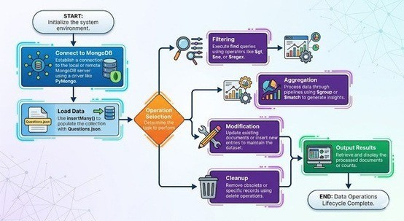
The flow diagram illustrates the project path:

Source Data:
The source data used in this project consists of crime records manually created for educational and analytical purposes. Each crime record contains detailed information about a criminal case.
The dataset includes:
- Crime ID
- Criminal Name
- Crime Type
- Location
- Severity Level
- Fine Amount
- Evidences
Sample Record:
{
"CrimeID": "C1001",
"CriminalName": "Karthik",
"CrimeType": "Theft",
"Location": "Bangalore",
"SeverityLevel": 9,
"FineAmount": 150000,
"Evidences": ["Mobile", "Fingerprint", "CCTV"]
}
The dataset is stored as BSON documents inside MongoDB.

Department of AI&DS, DrHNNCE 5


Steps to Import a JSON File in MongoDB Compass

    - Open MongoDB Compass.
    - Connect to the database.
    - Click Create Database.
    - Enter:
Database Name Collection Name
    - Click Create Database.
    - Open the collection.
    - Click Add Data → Import File.
    - Select the JSON file from your computer.
    - Choose file type as JSON.
    - Click Import.
    - The JSON data will be added to the collection.
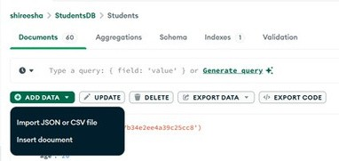


Steps to Import a CSV File in MongoDB Compass

      - Open MongoDB Compass.
      - Connect to MongoDB.
      - Select the database and collection.
      - Click Add Data → Import File.
      - Select the CSV file.
      - Choose file type as CSV.
      - Check the column names and data types.
      - Click Import.
      - The CSV data will be stored in the collection.
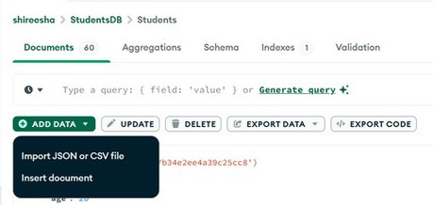


Department of AI&DS, DrHNNCE 6


3.2 Tech Stack Used:
MongoDB: MongoDB is a NoSQL database used to store crime records. It supports flexible document-based storage without requiring a fixed schema..
- MongoDB Compass: MongoDB Compass is a graphical tool used to manage MongoDB databases. It helps in importing data, viewing documents, and executing queries.
- MongoDB Shell : a command-line interface for interacting with MongoDB. It is used to perform CRUD operations and execute database queries
- JSON in Java (org.json): JSON is a lightweight data format used to represent crime records. It enables easy storage, import, and retrieval of data in MongoDB..

3.3 Explanation of the Data Question ID: Q-101
Description: A unique alphanumeric identifier assigned to the Crime Analysis System MongoDB exercise containing 10 sub-questions (a through j) covering CRUD operations, filtering, aggregation, and update/delete operations.
Purpose: Ensures the complete crime database exercise can be uniquely identified within the question dataset, useful for referencing in lab manuals, tracking student submissions, evaluating individual performance across all MongoDB operations, and organizing database practical examination questions.

Q-101a

Description: Find crimes whose fine amount is greater than 100000 using a comparison filter.
Purpose: Tests the ability to perform basic read operations with greater-than conditions, essential for crime data analysis and identifying cases involving high monetary penalties.

Q-101b

Description: find crimes that are not of type "Theft" and have a SeverityLevel greater than 7 using multiple conditions.
Purpose: Evaluates understanding of logical operators ($ne, $gt) and combining multiple filter conditions, critical for complex crime investigations and identifying high-severity criminal cases.

Q-101c

Description: Find criminals whose names start with 'Kar' and display only specific fields (CrimeID, CriminalName, CrimeType, Location).
Purpose Assesses pattern matching using regular expressions (^ prefix) and field projection techniques, important for search functionality and optimizing query results by returning only necessary crime-related data.

Department of AI&DS, DrHNNCE 7


Q-101d

Description Find criminals whose names end with 'son' and display only specific fields (CrimeID, CriminalName, CrimeType, Location).
Purpose Tests regular expression pattern matching using the suffix ($) operator and field projection, useful for criminal name pattern analysis and efficient retrieval of crime-related information.

How the data is used
- Aggregation Operations: To summarize and analyze crime data, such as counting crimes by location, identifying high-severity crimes, or calculating the total fine amount associated with different crime types
- Queries: To filter and retrieve specific subsets of crime records, such as crimes occurring in a particular city, crimes with a severity level above a certain threshold, or records associated with a specific crime type.
Updates: To modify existing crime records, such as correcting location details, updating fine amounts, modifying evidence information, or revising crime-related data.
Deletion: To remove data that is no longer relevant or accurate, such as duplicate crime records, incorrectly entered information, or obsolete records that no longer need to be maintained in the database..

Department of AI&DS, DrHNNCE 8


Chapter 4

Analytical Questions and MongoDB Solutions

- Write a MongoDB query to find the products whose stock quantity is greater than 100000.
db.Crimes.find({ "FineAmount": { $gt: 100000 } })

OUTPUT:
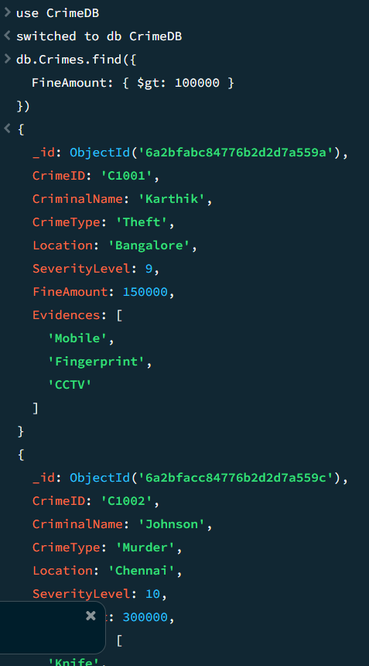

Department of AI&DS, DrHNNCE 9


Write a MongoDB query to find the crimes that are not of type "Theft" and whose SeverityLevel is greater than 7..

db.Crimes.find({

"CrimeType": { $ne: "Theft" },

"SeverityLevel": { $gt: 7 }

})

OUTPUT: 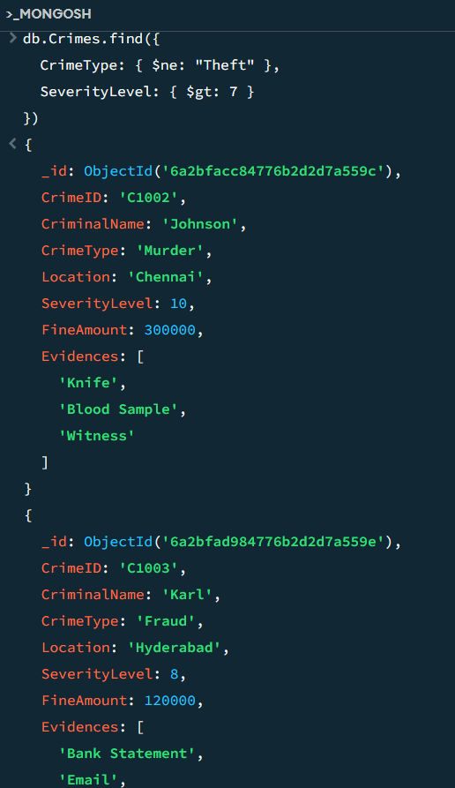

Department of AI&DS, DrHNNCE 10


- Write a MongoDB query to find the CrimeID, CriminalName, CrimeType and Location for those criminals whose names start with "Kar"

db.Crimes.find(

{

"CriminalName": /^Kar/

},

{

"_id": 0,

"CrimeID": 1,

"CriminalName": 1,

"CrimeType": 1,

"Location": 1

}

)

OUTPUT: 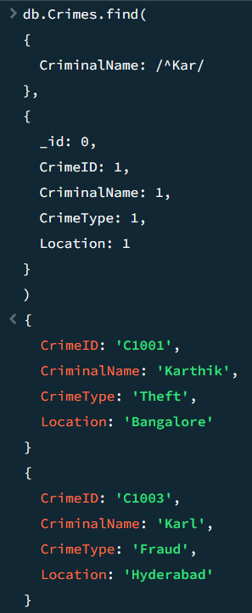

Department of AI&DS, DrHNNCE 11

- Write a MongoDB query to find the CrimeID, CriminalName, CrimeType and Location for those criminals whose names end with "son".

db.Crimes.find(

{

"CriminalName": /son$/

},

{

"_id": 0,

"CrimeID": 1,

"CriminalName": 1,

"CrimeType": 1,

"Location": 1

}

)OUTPUT: 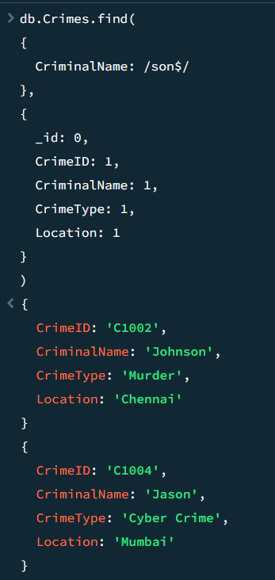

Department of AI&DS, DrHNNCE 12

- Write a MongoDB query to update the Location of the crime with CrimeID "C1001" to Chennai.


db.Crimes.updateOne(
{
"CrimeID": "C1001"
},
{
$set: {
"Location": "Chennai"
}
}
)

OUTPUT: 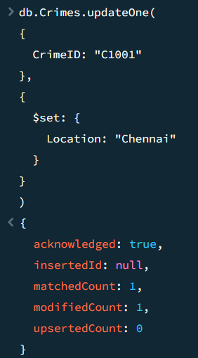

- Write a MongoDB aggregation query to calculate the total number of crimes location-wise using $group.

db.Crimes.aggregate([

{

$group: {

_id: "$Location",

TotalCrimes: { $sum: 1 }

}

}])OUTPUT: 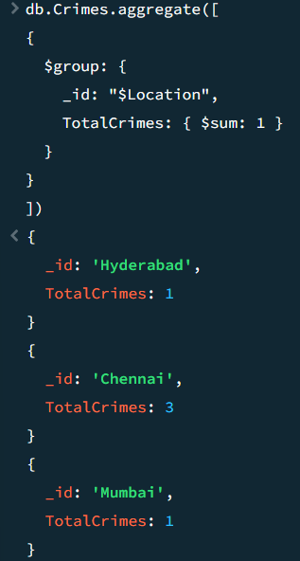

Department of AI&DS, DrHNNCE 13


- Write a MongoDB aggregation pipeline query using $match to display crimes whose SeverityLevel is less than 8.

db.Crimes.aggregate([

{

$match: {

"SeverityLevel": { $lt: 8 }

}

}

])

OUTPUT: 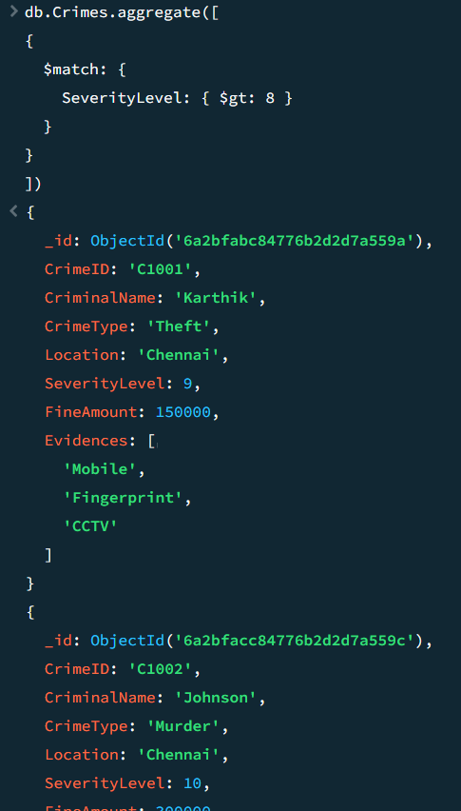

Department of AI&DS, DrHNNCE 14


- Write a MongoDB query using $slice to display the first 2 evidences of each crime.

db.Crimes.find(

{},

{

"_id": 0,

"CrimeID": 1,

"Evidences": { $slice: 2 }

}

) OUTPUT: 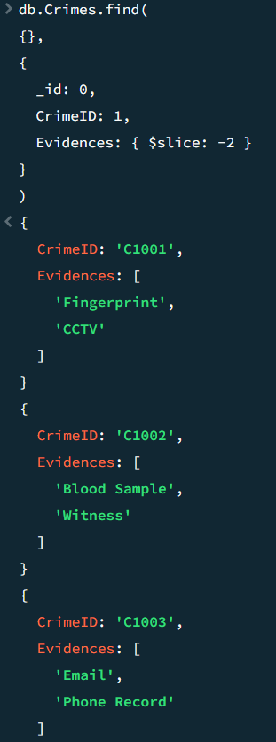

Department of AI&DS, DrHNNCE 15


Write a MongoDB query to insert a new crime document into the collection.

db.Crimes.insertOne({
"CrimeID": "C1006",
"CriminalName": "Ramesh",
"CrimeType": "Robbery",
"Location": "Mysore",
"SeverityLevel": 8,
"FineAmount": 130000,
"Evidences": ["Gun", "CCTV", "Witness"]
})

OUTPUT: 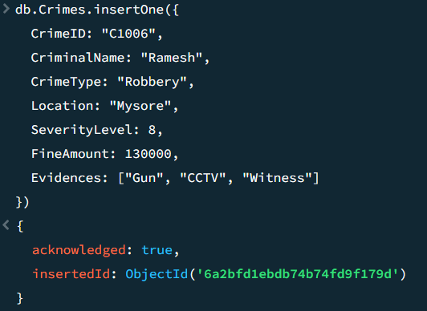

- Write a MongoDB query to delete the crime whose CrimeID is C1001.

db.Crimes.deleteOne({
"CrimeID": "C1001"
})

OUTPUT: 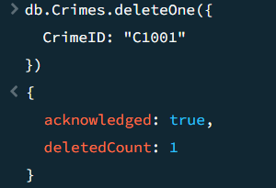

Department of AI&DS, DrHNNCE 16


Chapter 5

Additional Technologies Used

- JSON in Java (org.json)
Purpose: Data Parsing and Manipulation
• Structured Crime Records: JSON is used to represent crime records in a structured format containing fields such as CrimeID, CriminalName, CrimeType, Location, SeverityLevel, FineAmount, and Evidences.
• Data Import: JSON files are imported into MongoDB Compass, allowing crime records to be loaded efficiently into the Crimes collection.
• Flexible Data Representation: JSON supports nested objects and arrays, making it suitable for storing evidence details and other crime-related information.

MongoDB Java Synchronous Driver (mongodb-driver-sync) Purpose: Database Integration and Execution
• Database Connection Management: MongoDB Compass provides a graphical interface to connect to local or remote MongoDB servers and manage databases.
• CRUD Operations: MongoDB Shell and Compass are used to perform Create, Read, Update, and Delete operations on crime records.
• Aggregation and Analysis: MongoDB supports aggregation pipelines such as $group, $match, and $slice to analyze crime data and generate meaningful insights.
• Document Storage: Crime records are stored as BSON documents, enabling efficient retrieval and flexible schema design.

Summary
- JSON: Used for storing, organizing, and importing crime data into MongoDB. It provides a structured format for representing crime records and evidence information.
- MongoDB Compass and MongoDB Shell: Used for database management, query execution, CRUD operations, and crime data analysis through MongoDB's powerful querying and aggregation features.

This combination of JSON, MongoDB Compass, and MongoDB Shell provides a simple and effective platform for storing, managing, and analyzing crime-related data in the Crime Analysis System.
.

Department of AI&DS, DrHNNCE 17


Chapter 6

Conclusion

The Crime Analysis System laboratory exercise provides a practical introduction to MongoDB database operations in the context of crime data management. Through a series of structured tasks, the exercise successfully connects theoretical NoSQL concepts with real-world implementation. Students gain experience in storing, retrieving, updating, and analyzing crime records using MongoDB collections and documents, helping them understand the importance of database management in law enforcement and crime investigation systems.

The laboratory effectively develops proficiency in fundamental CRUD (Create, Read, Update, Delete) operations along with advanced querying techniques. Students learn to filter records using comparison operators, perform pattern matching with regular expressions, update existing crime information, and insert or remove records as required. Aggregation operations such as $group and $match further enhance analytical capabilities by enabling meaningful crime data analysis based on location, severity level, and other attributes.

The exercise demonstrates several educational strengths, including a progressive learning structure, practical real-world relevance, and comprehensive coverage of MongoDB features. By working with crime-related datasets, students gain valuable hands-on experience in document-oriented databases, data analysis, and query optimization. Overall, the Crime Analysis System serves as an effective learning platform for developing practical MongoDB skills that can be applied in database-driven applications and analytical systems.

Department of AI&DS, DrHNNCE 18

